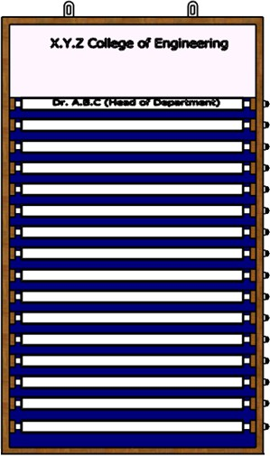

FRONT VIEW

Novelty resides in the shape and configuration of Letter Board as illustrated.
No claim is made by virtue of this registration in respect of any mechanical or other action of the mechanism or in respect of any mode or principle of construction of Letter Board.
No claim is made by virtue of this registration to any right to the exclusive use of words, letters, numbers, colours, trademarks or extraneous matter appearing in the representation.

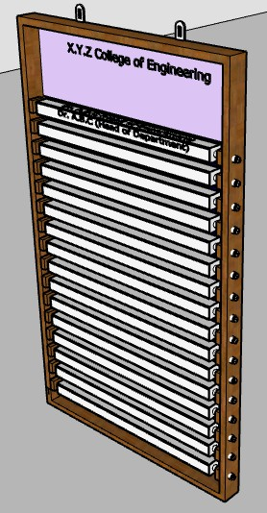

PERSPECTIVE VIEW

Novelty resides in the shape and configuration of Letter Board as illustrated.
No claim is made by virtue of this registration in respect of any mechanical or other action of the mechanism or in respect of any mode or principle of construction of Letter Board.
No claim is made by virtue of this registration to any right to the exclusive use of words, letters, numbers, colours, trademarks or extraneous matter appearing in the representation.

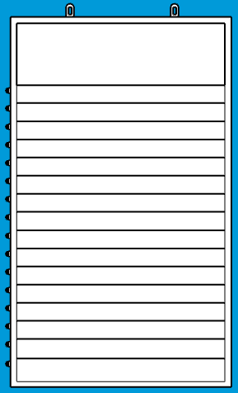

BACK VIEW

Novelty resides in the shape and configuration of Letter Board as illustrated.
No claim is made by virtue of this registration in respect of any mechanical or other action of the mechanism or in respect of any mode or principle of construction of Letter Board.
No claim is made by virtue of this registration to any right to the exclusive use of words, letters, numbers, colours, trademarks or extraneous matter appearing in the representation.

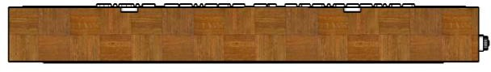

TOP VIEW

Novelty resides in the shape and configuration of Letter Board as illustrated.
No claim is made by virtue of this registration in respect of any mechanical or other action of the mechanism or in respect of any mode or principle of construction Letter Board.
No claim is made by virtue of this registration to any right to the exclusive use of words, letters, numbers, colours, trademarks or extraneous matter appearing in the representation.



BOTTOM VIEW

Novelty resides in the shape and configuration of Letter Board as illustrated.
No claim is made by virtue of this registration in respect of any mechanical or other action of the mechanism or in respect of any mode or principle of construction of Letter Board.
No claim is made by virtue of this registration to any right to the exclusive use of words, letters, numbers, colours, trademarks or extraneous matter appearing in the representation.

LEFT SIDE VIEW

Novelty resides in the shape and configuration of Letter Board as illustrated.
No claim is made by virtue of this registration in respect of any mechanical or other action of the mechanism or in respect of any mode or principle of construction of Letter Board.
No claim is made by virtue of this registration to any right to the exclusive use of words, letters, numbers, colours, trademarks or extraneous matter appearing in the representation.

RIGHT SIDE VIEW

Novelty resides in the shape and configuration of Letter Board as illustrated.
No claim is made by virtue of this registration in respect of any mechanical or other action of the mechanism or in respect of any mode or principle of construction of Letter Board.
No claim is made by virtue of this registration to any right to the exclusive use of words, letters, numbers, colours, trademarks or extraneous matter appearing in the representation.

